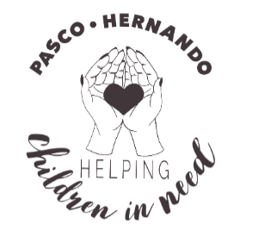

## Introduction

First of all, thank you so much for considering me for the TI Founders Community Impact Award. I am very excited for the opportunity for our organization to be recognized for all of the recent accomplishments. Below, I will tell you about how this all started, how the community has come together and some of our major accomplishments over the past 12 weeks. I will also spread in some pictures to hopefully give you a good idea on why this group should be recognized. In addition, I will tell you how the award will be utilized.

## Mission

Helping Children in Need Inc. is a newly formed nonprofit organization.

Our Mission is to be the **light in a sometimes dark world**, to remind others that we are **unified and not separated**. Together, we can **transform hearts by one act of kindness at a time** by providing food and clothing to children in need.

## How it Began

On Christmas day, my mother passed away. She had been a huge part of my life and I spent many years as her caregiver. Thankfully, Texas Instruments allowed me to relocate closer to her to spend the last 8 years of her life with her. We made many beautiful memories with family and her four young grandchildren that will be cherished forever. After her passing, I fell into a deep depression and struggled with what I would do next. I wanted to help people, yet I just didn’t know how. One day, I finally decided that I would just do something. One Friday night, I created a Facebook post asking for families of children in need promising that I would do whatever I could do to help them. Out of that request, I got 8 families who requested assistance. Several people also offered to help. Early Saturday morning, I went shopping for four families who confirmed and who were in dire need of assistance.

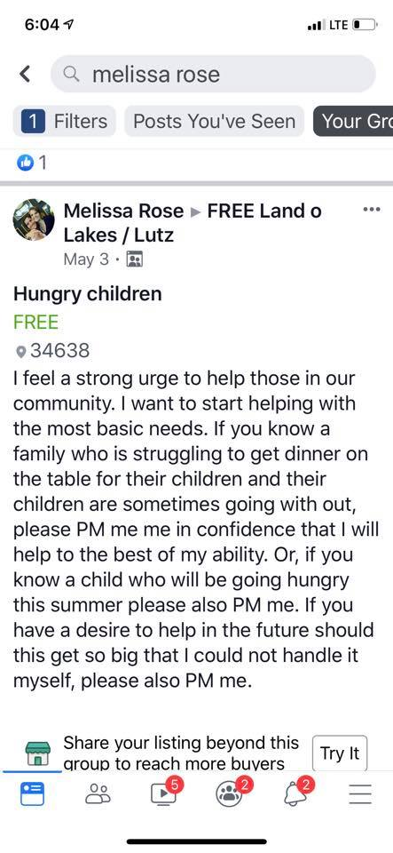

Figure The post that started it all.

From that single post, several people contacted me and wanted to be a part of what I was doing. I started a Facebook group called [Pasco Hernando Helping Children in Need](https://www.facebook.com/search/top/?q=pasco%2Fhernando%20helping%20children%20in%20need%20inc.&epa=SEARCH_BOX) for all of the helpers. I also started another Facebook group called Pasco Hernando Children in Need for all of the families who needed help. The helpers poured in. Eleven days after we began, we had over 300 people join our group who wanted to help. Today, we have over 1,000. Of those 1,000 people, 56 of them are very consistent helpers and do things from Fundraising to coordinating or even transporting and sorting. I will go into detail shortly how this is all structured. In the first three weeks of operation, all of our helpers and volunteers helped to serve over 510 people in our community!

## How it is Structured

We have so many volunteers, we had to think quickly on how to structure the people in our group so that we could be the most impactful and least wasteful of time and resources. After all, most of us have full time jobs.

We have what are called HUBS around two counties who store food and clothing for children in need. Currently, we have five HUBS in operation. A person in need will fill out a short form requesting food and clothing for their family. The Needs Coordinator will determine which HUB is the closest to the person in need and will coordinate with the HUB owner to make sure the need is met. We also have helpers around both counties who do things such as sort clothes, transport goods locally, cross county, plan fundraisers, and shop for the HUBS.

In addition to all of that, we have a Diaper and Wipes HUB who strictly stores diapers and wipes for our local HUBS. We also have a Donations coordinator who will coordinate donation drop offs with our local HUBs.

## Community Impact

The community response has been huge. Like I said previously, we have over 1000 helpers in our group and over 56 consistent volunteers. In addition to that, people have donated over $5,754 in cash towards our mission. The cash has been used for several things such as providing shelter to families who are homeless, purchasing perishables for our local HUBS as well as providing help to families who are having trouble keeping their electricity on.

Below are just some of the specific cases that we’ve helped with:

* Found a family of five (Children ages 7,4 and 1) who were living in their van for a month a home! We also helped the father find two jobs!
* Found shelter for a grandfather and his granddaughter who were evicted
* Fundraised for a mom who has stage four cancer and whos son is disabled. We were able to send them to a water park resort for four days to spend quality time while they still have the time to spend together.
* Fundraised for a homeless mom and nine year old. We were able to put them up in a hotel for a week. The mom had just recently started a job and was not getting paid for several weeks.
* Fundraised for a mother who has three children (one of whom has a serious heart condition and will require surgery) We were able to pay her rent for the month.
* Fundraised for a teenager and his mom. The teenager was selling all of his childhood posessions to help his mom pay bills. His father passed away in May. We were able to pay his mothers bill and get him another xbox that he sold.

To date, due to the huge community response, we have been able to provide services to over 1800 people! The help we’ve provided ranges from food and clothing to shelter and help with utility bills.

Two local news stations also interviewed us about the impact we were having on the community. Those stories can be viewed here:

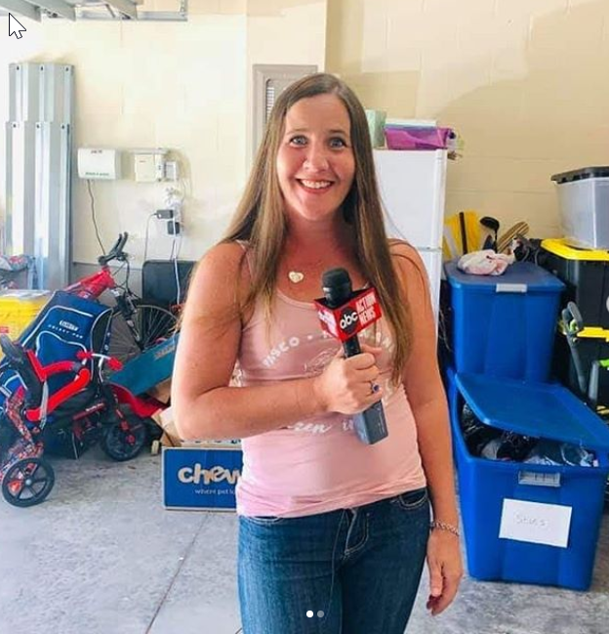

Figure Getting ready for the ABC Action News Interview

10 [News](https://www.wtsp.com/article/news/community-outreach-making-big-strides-in-early-days/67-e9e70b10-affa-42fd-83bf-d78460df9fc3) with Bobby Lewis

[ABC Action News – Sean Daly](https://www.abcactionnews.com/news/region-pasco/mothers-passing-inspires-land-o-lakes-woman-to-create-an-outreach-group-helping-kids-in-need)

In addition to necessities that we provide children and families in need, we are also collected donations and provided school supplies to 107 children! This would not be possible without our generous donors who provided over 5,900 individual school supplies!

# 

Figure - School Supply Donations from Community

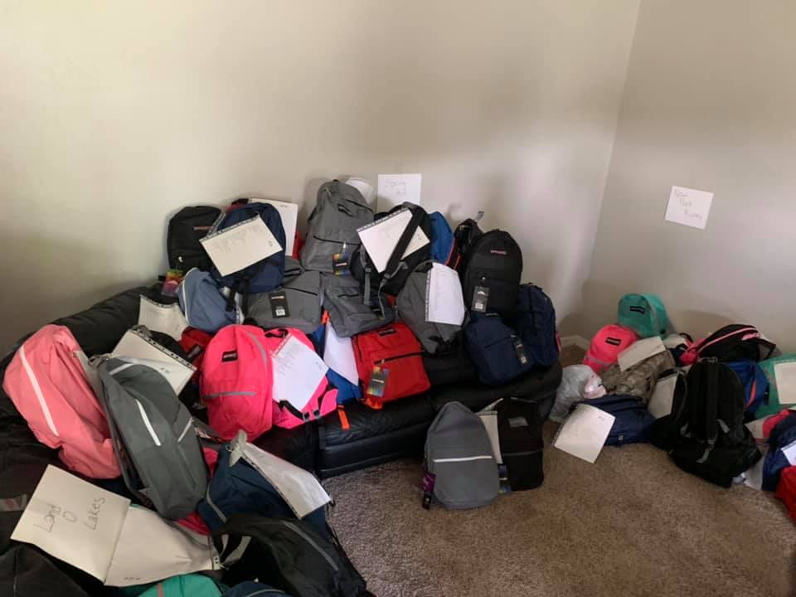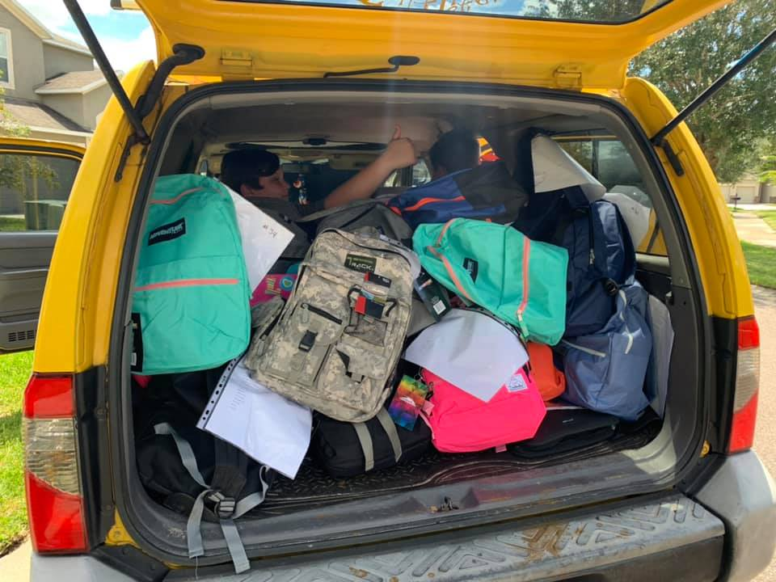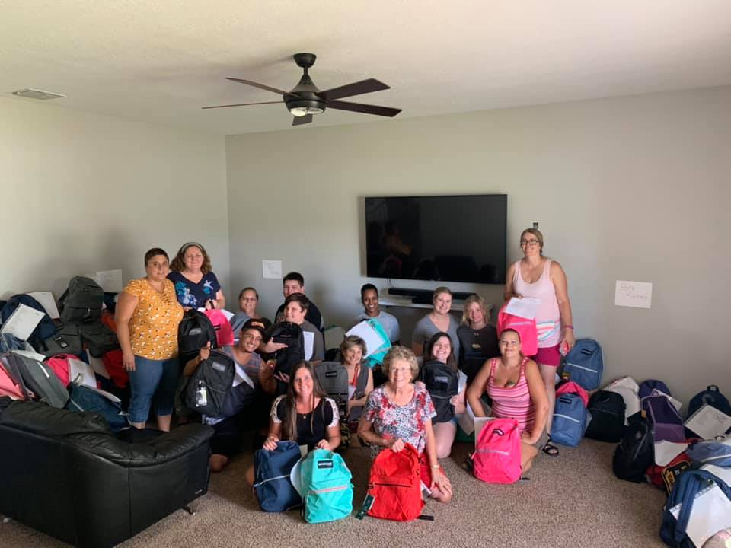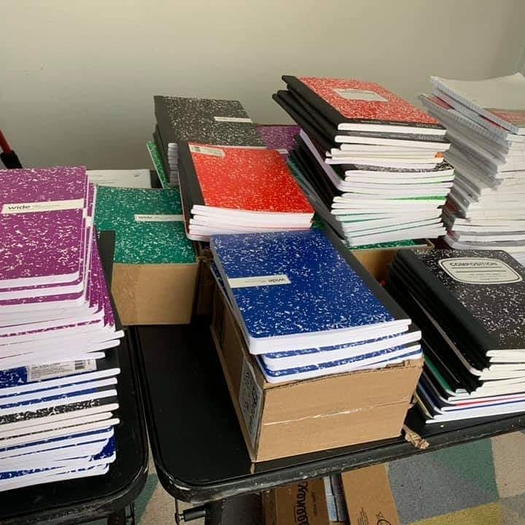

In addition to the school supply drive, we have 10 businesses who are supporting our cause and who have allowed us to setup a “Food Drive” box at their business to collect things such as non-perishables and clothing.

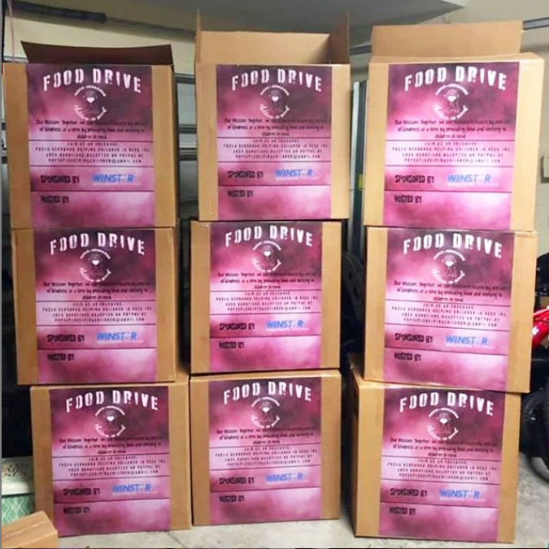

Figure Food Drive Boxes for businesses

Our donors are like none other. We have had hundreds of donors who have provided clothing, money, school supplies, perishables, non-perishables and their valuable time.

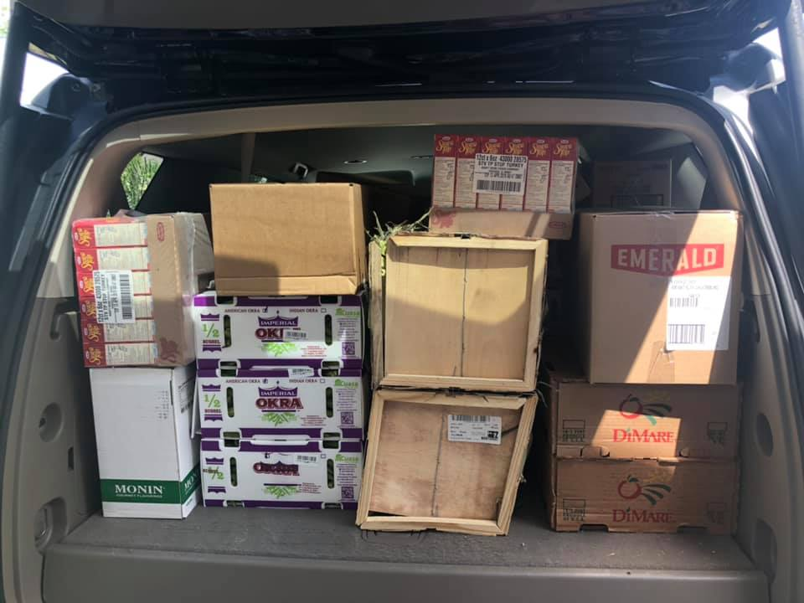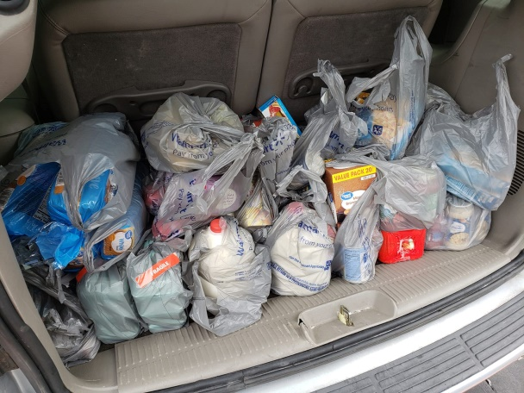

Figure 5- Donations of Food

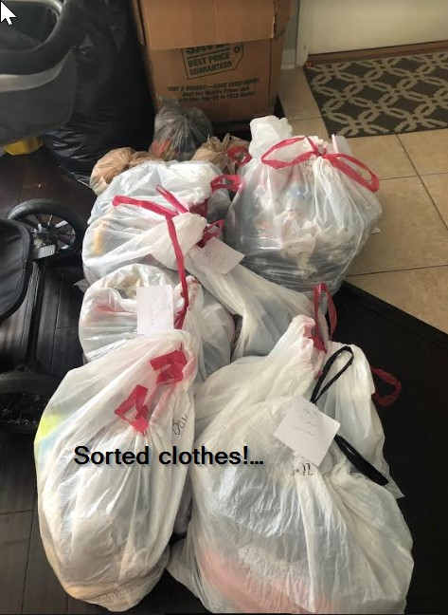

Figure Clothing Donations

## Plans

Since we’ve been notified that we are officially a non-profit, we have been very busy looking for resources to try to receive help. So far, our dedicated donors continue to support us while we look for funding.

We have lots of things in work to keep this movement going and to transform as many people as possible through our good deeds.

We have five fundraisers planned - two car washes which will take place in August as well as October. We have two food drives planned where we will sit outside of a local grocery store and accept non-perishables and cash donations.

In addition to those, we are also planning a charity golf tournament! Almost 100% of the funds raised from these fundraisers will go directly back to the community who needs us. The only overhead costs we are incurring will be to have some banners, signs and t-shirts made for our fundraising events. We are actively trying to find businesses who will sponsor this activity to minimize the overhead costs.

In December, we will partner with a local Santa Claus to hand out gifts that we receive through donations to children in need.

## Summary

In closing, I want to thank you again for this opportunity. $10,000 will help so many children in our community. We plan to use it to continue to help those families who are in dire need of food and clothing. In addition, we intend to use it for emergency purposes where a family may be at risk of becoming homeless or having their utilities shut off. 100% of the funds will go back to those in the community who need us.

If you are interested in learning more before you make your decision, you are more than welcome to follow us on Instagram at [@helpingchildreninneed](https://www.instagram.com/helpingchildreninneed/) or on our public Facebook Page [Helping Children in Need Inc.](https://www.facebook.com/helpingchildreninneedinc/?modal=admin_todo_tour)

In closing, I want to share some of the nice things that our community members have said about us:

